Strategy Guide — When to use this procedure
The procedure is: check logistic assumptions → fit a binary logit → move the threshold → read the ROC → handle imbalance. It is a classification workflow, not a causal one.

When this package is the right next step
- You already know the outcome is a clean 0/1 and you can name the positive class.
- Features are numeric (or dummy-coded) and you expect a roughly linear log-odds.
- You can tolerate a linear decision surface and want coefficients you can read.
- The painful error is identifiable (FN vs FP) so a threshold conversation is possible.
- n is hundreds+, minority class still clears ~10 events per planned feature.

Top 10 applications
- Diagnostic classification from lab or imaging features (this lab).
- Credit-default / loan-approval probability (PD scorecards).
- Subscription churn: will this account cancel in 30 days?
- Marketing conversion: did the recipient click or buy?
- Fraud / AML alert triage, with a low threshold and a human in the loop.
- Hospital readmission or ICU-transfer risk inside a short window.
- Manufacturing pass/fail from a handful of sensor summaries.
- Survey / election binary items (support vs oppose) with a short covariate list.
- Online experiment analysis when the outcome is a conversion flag.
- Ecology presence–absence models with a small set of habitat covariates.

When it is not appropriate
- Three or more unordered classes — use multinomial logit or a dedicated multiclass model.
- Repeated rows on the same person, visit, or hospital — independence is broken; use GEE or a mixed-effects logit.
- Minority class has far fewer than 10 events per feature — MLE wanders; shrink, cut features, or collect data.
- regplot is not sigmoidal — the logit is curved. Add splines / a GAM / a tree ensemble.
- You need a causal effect of a treatment — a risk score is not an identification strategy.
- Prevalence is tiny (≪1%) and you only have a handful of positives — weights cannot invent events.
- The real target is a duration, a count, or a dose — use survival, Poisson, or linear models.
- Features are images, raw text, or other ultra-high-dimensional inputs — start with a representation model, not raw logit.

How to reuse the template
Open LogReg_Assumptions_Reusable_Template.ipynb. Change DATA_PATH, TARGET, POSITIVE_MAP, FEATURES, ID_COL. Run the assumption cells before you celebrate the AUC. Copy the simulation cell when a stakeholder asks “what if we only had 200 rows?”.

Responsible use (clinical and otherwise)
Wisconsin Diagnostic Breast Cancer is a clean teaching file. It is not a licence to deploy a four-feature logit as a diagnostic device. Thresholds belong to the people who own the false-negative budget. Always write the sentence “this is not medical / credit advice” when the memo leaves the classroom.
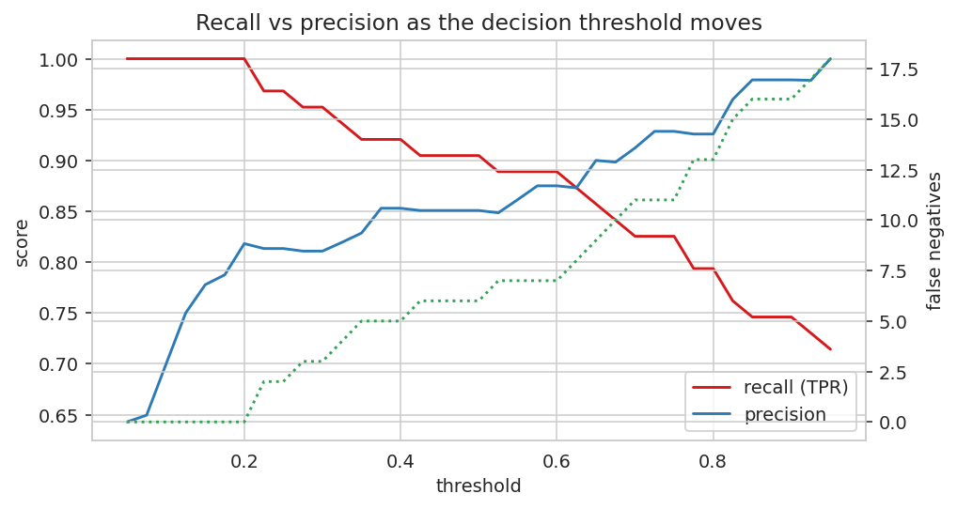
Recall falls and precision rises as the cut moves right; false negatives (dotted) climb. That picture is the whole policy conversation.

